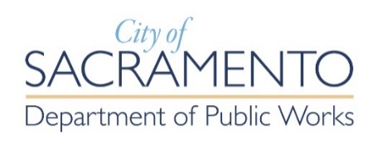
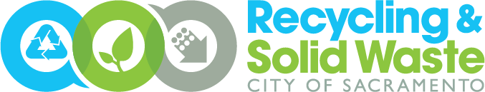
Post-Event Diversion Report
Organizers of events of 2,000+ people that charge an admission price must report on the diversion (recycling) efforts that were implemented and the amount of material diverted and disposed at the event.

Please complete and return this form to the Recycling and Solid Waste Division, Commercial Waste Compliance team at wastecompliance@cityofsacramento.org within 60 days of the completion of your event. Failure to provide a post-event report may result in the denial of future requests for special event permits.

1. Contact Information
Event Name: Click or tap here to enter text.
Event Date(s): Click or tap here to enter text.
Event Contact Name: Click or tap here to enter text.
Title: Click or tap here to enter text.
Email: Click or tap here to enter text. Phone Number: Click or tap here to enter text.
Company Address: Click or tap here to enter text.

2. Tonnage Information
Provide the overall tons of each waste stream generated at the event. Contact your waste hauler to obtain this information. If data is in pounds, please indicate this.

Tons of Waste Disposed: Click or tap here to enter text.
Tons of Recyclables Diverted: Click or tap here to enter text.
Tons of Organics Diverted: Click or tap here to enter text.

3. Waste Diversion Efforts
Describe the diversion and waste reduction efforts that were implemented at the event:
Click or tap here to enter text.

