### 4

2

4

"^!$

Elkhorn Blvd

2 u

6 6

W

l b Cen

2

2

4

### 2

4

idge2cross

2

ter Dr 2 2

**Street Classifications**

### 2

**MAP M-1: CIRCULATION DIAGRAM**

2

Rio Linda Blvd 2

2 Dry Creek Rd

4

2 Raley Blvd

6 6 ain Ave 2 2 2

4

4

2

# !$c"

2 Bell Ave 2

N Market Blv

te Blvd

2

4

8

2

4

4

Arena Blv

El Centro Rd

### 2

2

4

Juan Rd

San

4

2

6

2

### 2

3

2

Norwood Ave 4

ilver Eagle Rd

2

2

4

North Ave

1. Grand Ave 2

2

2

2 2

1. South Ave 3

W El Camino Ave

2

2

4

2

rd St

2

### 2 2 4

¦02/El Camino Ave

# $c"!

4

# c"$! A½

ards Bl

Ethan Way

½I

4 4

Ad Alta Arden E

See the Downtown Inset Map for Detail

5

rd

x

2

2

4

4

E

v

6

### 4

1. Oaks Bl

r

6

# ½I

A e

llege Town Dr

Kiefer Blvd

2

2

2

9

65

oa a 2

d

2

4

### 2 2 4

2

2

som B

14th Ave

½A 2

4

21st Ave

2

Irvin Way

4

2

Fruitridge Rd

d

Power Inn Rd

2

65Th S

4

6

4

6

2

e 4 4 4 4

2

2

Fruitridge Rd

2

4

2

4

4

6

### 6 4 4

2

2 Lemon Hill Ave

4

47Th Ave

2

4

Elder Creek Rd 4 4

rin R 6 6 6 4 4

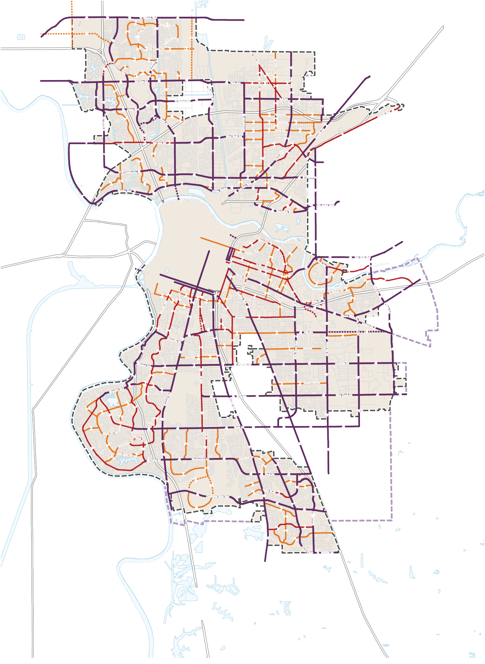

**Existing Roadways**

Freeway Arterial

Major Collector

Minor Collector Local Road

**Planned Roadways**

Arterial

Major Collector Minor Collector Local

Sacramento City Limit

Sphere of Influence Water

x

Number of Lanes

4

4

d

4

4

4

4

# AÎ

ver

4

4

4

o Meadowview Rd

4

4

4P

2

Ma d

4

4

4

ck R

umnes River Bl

Cos

v

4

4

^"!$

2

2

Brucevill6e R

kwy n

5 Sheldo

### 0 ½ 1 2 Miles

Source: City of Sacramento, 2023; Fehrs & Peers, 2023; Dyett & Bhatia, 2023

$!^"

## Richards

2

2

**Downtown Street Classifications**

Ad

**MAP M-2 CANDIDATE HIGH-FREQUENCY TRANSIT CORRIDORS**

Map M-2: Circulation Diagram

- Downtown Inset

2

2¦0/

I½

½I

$^"!

2

ÎA

2

24Th St

Franklin Blvd

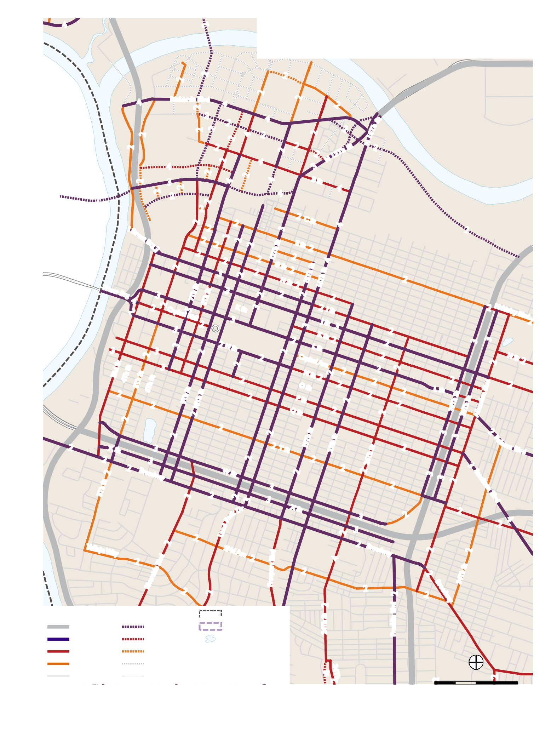

**Existing Roadways**

Freeway Arterial

Major Collector

Minor Collector Local Road

**Planned Roadways** Sacramento City Limit

Sphere of Influence

Water

x

Arterial

Major Collector Minor Collector Local

Number of Lanes

Source: City of Sacramento, 2021; Fehrs & Peers, 2021; Dyett & Bhatia, 2021

2

2

2

0 0.125

0.25 0.5 Mile